Муниципальное общеобразовательное учреждение
«Основная школа – интернат Краснооктябрьского района Волгограда»
(МОУ Школа – интернат)

Всероссийский конкурс для учителей
LET’S CELEBRATE!

Проектная работа
«Welcome to Russia’s Watermelon Capital!»
(по материалам проведения Фестиваля арбузов в городе Камышин Волгоградской области)
для учащихся 7 – 8 классов

Разработал:
учитель английского языка
высшей квалификационной категории
Лыжева Елена Анатольевна

г. Волгоград – 2019 г.

Методические комментарии
Назначение работы: актуализировать страноведческие знания, полученные при изучении темы «Английские праздники», применяя их к современному развитию российского культурного общества.
Возрастной уровень обучаемых: 7–8 классы.
Варианты применения материала на уроке или внеурочной деятельности: при изучении темы «Праздники в Британии и России», 7 класс, использование во внеурочной работе, на факультативе «Моя малая Родина», на Неделе знаний предметов гуманитарного цикла, при проведении интегрированных уроков по истории России и географии родного края.
Используемые формы, методы и технологии работы:
Формы работы: фронтальный и групповой опрос, работа в парах, письменная индивидуальная работа при составлении синквейнов по теме.
Методы работы: продуктивный, творческий, словесно-практический, репродуктивный, наглядный и объяснительно-иллюстративный (иллюстрации в тексте), мнемотехнические методы при объяснении незнакомых слов, методы контроля и самоконтроля, метод закрепления, проверки и оценки знаний учащихся, метод формирования навыков и умений применения знаний на практике, фронтальная работа, работа в парах, работа хором, индивидуальные ответы на вопросы учителя
Технологии работы:
– здоровьесберегающие технологии;
– игровые технологии;
– технология развития критического мышления при ответах на вопросы;
– технология работы с аудиовизуальными материалами.
Планируемые образовательные результаты:
• Предметные: уметь продуцировать письменное высказывание, уметь осуществлять диалоговое общение, понимать иноязычную речь и реагировать на неё, употреблять в речи изученный лексико-грамматический материал, уметь описывать российские праздники и фестивали;
• Метапредметные: умение адекватно, осознанно и логично строить речевое высказывание, умение работать по образцу, уметь работать с разными компонентами УМК, уметь критически и творчески оценивать материал;
• Личностные: вежливость, культура поведения, уметь работать в паре, уметь спланировать и согласованно выполнять совместную деятельность, уметь слушать собеседника и вести диалог.

The list of words
Сapital, watermelon, the best, tourist, event, district, annual, entertainment, August, September, bright, juicy, holiday, celebration, city's birthday, honour, southern Africa, to cultivate, century, the Tatars, old local legend, Russian tsar, tast, copper, to shout, local, grower, costume, creative, stroller contest, to take part in, funny, rind tossing, checker, bowling, carving, seed spitting, ride, scarecrow, participant, favourite, to connect to, museum, participant, to be able to, welcome, joke, during, held, the first, cucumber, donkey, container, shape, square, heart, berry, health benefits, consist of, natural low-calorie, antioxidant, vitamins, minerals, prevent, illnesses, free radical damage, bank, to be situated, between, cruze-ships.
- Match the pictures with these words
capital watermelon Russian tsar stroller contest scarecrow
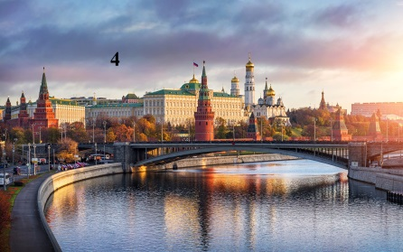
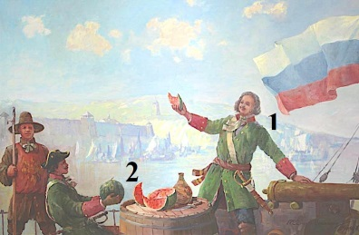
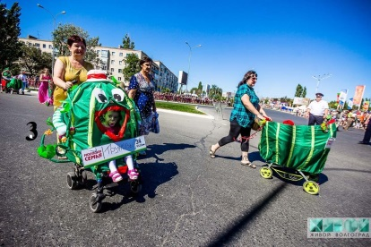
- Read the text quickly and tick ( √ ) the towns and cities it mentions

  - Manchester
  - Volgograd
  - New York
  - Uryupinsk
  - London
  - Moscow
  - Paris
  - Dmitrievsk
  - Kamyshin
  - Astrakhan
  - Rio de Janeiro
  - Saratov

- Read and listen
Welcome to Russia’s Watermelon Capital!
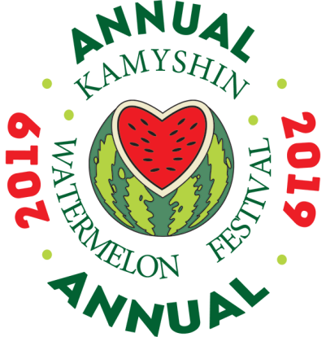
While Moscow is the political, business and financial capital, other cities take the top spot in more unusual categories.
Facts
Volgograd Region watermelon festival is one of the best tourist events in Russia’s Southern Federal District. It’s held in small town Kamyshin in the central part of Volgograd Region.
The Kamyshin Watermelon Festival is an annual Russian entertainment festival.
Similar, to Moscow City Day celebrations, the festival is held on the city's birthday at the end of August – beginning of September. Bright and juicy holiday attract more than 30,000 of visitors each year. The Kamyshin Watermelon Festival as Rio de Janeiro carnival lasts while its participants are able to have fun.
History of watermelon
The watermelon is from Africa.
It was cultivated in India and China in the 7th – 10th centuries.
The watermelon was brought to Russia by the Tatars in the 13th or 14th century.
Local legend
According to one old local legend, in 1722 Russian tsar Peter the Great visited Dmitrievsk (now Kamyshin) and tasted the local watermelons. He shouted “Very good fruit!” and ordered to make a copper's copy of watermelon.
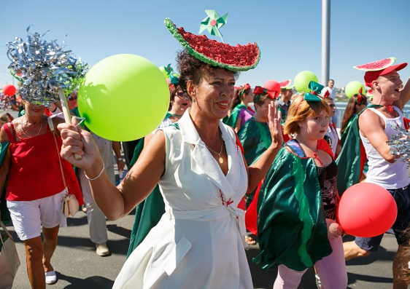
Activities and competitions
- Growers present watermelons heavier than 20 kilograms at the Largest Watermelon Contest.
- Local girls walk in the costumes of a watermelon at the Watermelon Defile.
- The most creative parents take part in the Watermelon Kids Baby Stroller Contest.
- Parents with older kids take part in the Watermelon Family Competition.
- Also visitors take part in different funny contests: watermelon rind tossing, watermelon checkers, watermelon bowling, watermelon carving, seed spitting, watermelon ride and scarecrow contests.
- A watermelon museum will soon open.
Welcome everyone!
No surprise – it’s so much fun!
Do you know?
- Local joke is babies in Kamyshin are found in watermelons.
- More than 60 tons of watermelon are annually eaten up and given as a gifts during the Festival.
- The Festival was held here for the first time in 2007.
- “Harbuza” is an Iranic word, meaning “cucumber as big as donkey”.
- In Japan people grow watermelons in special containers of unusual shapes – square and heart.
- The watermelon is a berry.
Health benefits of eating the watermelon
The watermelon consists of 98 % of water. It is a natural low-calorie and antioxidant food plus vitamins and minerals that can prevent a lot of serious illnesses and free radical damage.
How to get to Kamyshin?
Kamyshin is situated on the right bank of the Volga River in Volgograd Region.
It’s situated between two big cities – Volgograd and Saratov.
You can get there by car, train or cruze-ships.
If you are interesting in visiting the Kamyshin Watermelon Festival just let us know!
- Circle the correct words:
- Volgograd / Moscow is the political, business and financial capital of Russia
- The Kamyshin Watermelon Festival is a weekly / an annual Russian festival.
- Bright and juicy holiday attract more than 20,000 / 30,000 of visitors each year.
- The watermelon was cultivated in India and Korea / China.
- In 1722 Russian tsar Peter the Great / Ivan the Terrible tested the watermelon.
- Growers present pumpkins / watermelons heavier than 20 kilograms at the Contest.
- Girls walk in the costumes of a Snow Maiden / watermelon at the Defile.
- 60 tons / 16 kg of watermelon are eaten up during the festival.
- The Kamyshin Watermelon Festival was held here for the first time in 2017 / 2007.
- An Iranic word “Harbuza” means “cucumber as big as bear / donkey”.
- You can get to Kamyshin by car, train or cruze-ships / camelback.
- Answer the questions:
- Who brought the watermelon to Russia? (The Tatars did)
- Napoleon was the first watermelon festival taster, wasn’t he? (No, he wasn’t. Peter the Great was the first watermelon festival taster)
- What monument did Peter the Great order to make in honour of watermelon in 1722? (a copper's copy of watermelon)
- What competitions do parents take part in at the Festival? (the Watermelon Kids Baby Stroller Contest and the Watermelon Family Competition)
- What different funny contests do visitors take part in at the Festival? (watermelon rind tossing, watermelon checkers, watermelon bowling, watermelon carving, seed spitting, watermelon ride and scarecrow contests at the festival)
- What unusual shapes of watermelons do Japanese people grow in special containers? (square and heart)
- Is the watermelon a fruit? (No, it isn’t. It’s a berry)
- What are health benefits of eating the watermelon? (a natural low-calorie, antioxidant food, vitamins and minerals, can prevent a lot of serious illnesses and free radical damage)
- How can you get to Kamyshin? (by car, train or cruze-ships)
- What two big cities are situated nearby Kamyshin? (Volgograd and Saratov)
- Read the text about Russia’s watermelon capital again. Say if these statements true or false T /F
- A watermelon museum won’t soon open. F
- According to the local joke babies in Kamyshin are found in cabbage. F
- 10 tons of watermelon are eaten up and given as a gifts during the Festival. F
- The Kamyshin Watermelon Festival was held here for the first time in 2017. F
- The English name for "watermelon" is “arbuz”. F
- The word “harbuza” means “cucumber as big as donkey”. T
- In the USA people grow watermelons in unusual shapes. F
- The watermelon is a berry. T
- The watermelon consists of 98 % of water. T
- Kamyshin is situated on the left bank of the Volga River. F
- Taking the given cinquain as an example, create some lines about “Watermelon”, “Watermelon Capital”
Kamyshin
Small and interesting
Visit, grow, take part in
Welcome to the town’s
Festival

Список используемой литературы и интернет-источников
- Комарова Ю.А. Английский язык: учебник для 7 класса. М.: «Русское слово», 2017 с.21-32, 132,133
- Annual "Kamyshin Watermelon Festival" [Электронный ресурс] // URL: https://arbuzfest.ru/en.aspx (Дата обращения: 21.11.2019).
- Kamyshin Watermelon Festival Материалы Википедии: [Электронный ресурс] // Википедия
URL: https://en.wikipedia.org/wiki/Kamyshin_Watermelon_Festival (Дата обращения: 21.11.2019).
- Russia’s southwestern Volgograd Region is hosting a traditional watermelon festival on Saturday. [Электронный ресурс] // URL: https://sputniknews.com/russia/201508291026325482/ (Дата обращения: 21.11.2019).
- Russia’s offbeat capitals: Famous for matches, watermelons, balloons and goats [Электронный ресурс] // URL: https://www.rbth.com/lifestyle/326968-russias-offbeat-capitals/amp (Дата обращения: 24.11.2019).
- The Kamyshin Watermelon Festival [Электронный ресурс] // URL: https://volgaland.volsu.ru/en/object/81 (Дата обращения: 23.11.2019).
- Watermelon Festival in Kamyshin [Электронный ресурс] // URL: http://eventsinrussia.com/en/event/20384 (Дата обращения: 24.11.2019).

