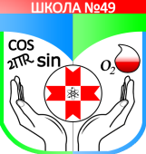  МУНИЦИПАЛЬНОЕ БЮДЖЕТНОЕ ОБЩЕОБРАЗОВАТЕЛЬНОЕ УЧРЕЖДЕНИЕ  «СРЕДНЯЯ ОБЩЕОБРАЗОВАТЕЛЬНАЯ ШКОЛА № 49» |  | «ОГЪЯДЫШЕТОНЪЯ 49-ТИ НОМЕРО ШОРЪЁЗО ШКОЛА» ОГЪЯДЫШЕТОНЪЯ КОНЬДЭТЭН ВОЗИСЬКИСЬ МУНИЦИПАЛ УЖЪЮРТ
_______________________________________________________________________________
426067, г. Ижевск ул. Труда, 18, тел. 212-711, e-mail: school49.78@mail.ru

Всероссийский конкурс для учителей

LET’S CELEBRATE!

Проект «Red Hair Festival»

Автор:
Роменская Инна Игоревна
учитель английского языка
МБОУ «СОШ № 49»
г. Ижевска

Red Hair Festival
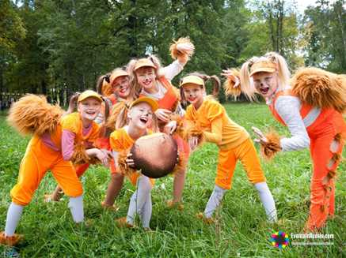
Red hair (or ginger hair) is found naturally in one to two percent of the human population.
Red hair varies in hue from a deep burgundy or bright copper, or auburn, to burnt orange or red-orange to strawberry blond.
Cultural reactions to red hair have varied from ridicule to admiration with many common stereotypes in existence regarding redheads. The term redhead has been in use since at least 1510.
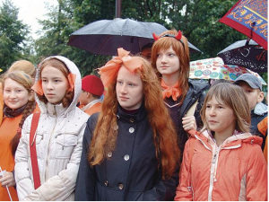
The "Red Festival" was based on the idea that the Udmurts are one of the most "red-haired" nations in the world. From year to year the festival expanded, filled with new ideas and venues, and gradually became the new cultural brand of Izhevsk. The Red Festival is a festival of unusual, bright and creative events that form new urban cultural space, promotions, projects, festivals and competitions, interactive entertainment and workshops. They take place in city parks, Central Square, open areas near shopping malls, in different organizations of the city.
70% of Udmurt people have red haired gene. Scientists around the world agreed that there is common gene among Udmut and Irish people.
Many Udmurt people have red hair and a festival to celebrate the day of red-haired people is held annually in Izhevsk since 2004. The Udmurts used to be semi-nomadic forest dwellers that lived in riverside communities. However, most Udmurts now live in towns.
Although the clan-based social structure of the Udmurts no longer exists, its traces are still strong and it continues to form modern Udmurt culture.
- Read the text about Red hair festival and complete the sentences with these words.
human population / Cultural reactions / "red-haired" nations
- Red hair (or ginger hair) is found naturally in one to two percent of the …………………
- …………………. to red hair have varied from ridicule to admiration with many common stereotypes in existence regarding redheads. The term redhead has been in use since at least 1510.
- The "Red Festival" was based on the idea that the Udmurts are one of the most ……………………….. in the world.
- Put the words in the correct order.
- the term «redhead» / since at least 1510/ has been in use /
- people / most Udmurt / live in Udmurtia
- have red hair / people / many Udmurt
- Read the text and answer the following questions.
- Since what time has the term «redhead» been in use?
- What is celebrated on this festival?
- How did cultural reactions to red haired people change?
Список литературы
- Голицынский, Ю.Б. Грамматика. Сборник упражнений.
- https://worddisk.com/wiki/Redhead/
- https://d1yn4c0k9exy1i.cloudfront.net/wiki/Red_hair
- http://eventsinrussia.com/en/event/18642
- http://eventsinrussia.com/en/event/18642 - фото
- https://russianpickle.files.wordpress.com/2010/03/udmurt_people_red.jpg - фото

